Technical Review

What is Technical Review
# Source: AI Source: Provided by: [Data Path: Persons Table -> ID Column: 1, Name_En Column: Motasem Essam] -> From: [Chatgpt (GPT‑5 Mini)] on [8/23/2025]
A Technical Review is a formal, structured type of review focused on evaluating a work product’s technical quality and conformance to specifications, standards, or best practices—without actually executing it.
It’s usually performed by technical peers (developers, architects, testers, subject matter experts), not end-users or business stakeholders.

Key Characteristics
# Source: AI Source: Provided by: [Data Path: Persons Table -> ID Column: 1, Name_En Column: Motasem Essam] -> From: [Chatgpt (GPT‑5 Mini)] on [8/23/2025]
- Focus:
  - Technical accuracy
  - Feasibility
  - Compliance with requirements and standards
  - Maintainability and performance considerations
- Led by: A trained moderator or facilitator (not always the author).
- Preparation: Reviewers receive the work product in advance, study it, and prepare comments.
- Formality: More structured than walkthroughs; issues are formally logged.

Typical Participants
# Source: AI Source: Provided by: [Data Path: Persons Table -> ID Column: 1, Name_En Column: Motasem Essam] -> From: [Chatgpt (GPT‑5 Mini)] on [8/23/2025]
- Moderator — runs the meeting and ensures the process is followed.
- Author — answers technical questions, explains logic.
- Reviewers/Experts — bring domain or technical expertise.
- Recorder/Scribe — documents findings.
- Manager (optional) — observes progress.

Example
# Source: AI Source: Provided by: [Data Path: Persons Table -> ID Column: 1, Name_En Column: Motasem Essam] -> From: [Chatgpt (GPT‑5 Mini)] on [8/23/2025]
📄 Artifact: Database design document for a hospital management system.
👤 Activity: A technical review meeting is scheduled with senior developers, the DBA, and the security architect.
- Reviewers check if foreign key constraints match the requirements in the ER diagram.
- Security architect points out that patient data encryption is not specified at the database level.
- DBA notes that some tables lack indexes needed for performance.
- All findings are logged in the review report.
- Author updates the design before implementation begins.

Benefits
# Source: AI Source: Provided by: [Data Path: Persons Table -> ID Column: 1, Name_En Column: Motasem Essam] -> From: [Chatgpt (GPT‑5 Mini)] on [8/23/2025]
- Detects design flaws early.
- Ensures compliance with coding/design standards.
- Improves system performance, maintainability, and security before coding starts.
- Saves cost by preventing expensive rework later.

Technical Review vs Walkthrough review
# Source: AI Source: Provided by: [Data Path: Persons Table -> ID Column: 1, Name_En Column: Motasem Essam] -> From: [Chatgpt (GPT‑5 Mini)] on [8/23/2025]
Here’s a side-by-side comparison of Technical Review vs Walkthrough so you can clearly see the differences:
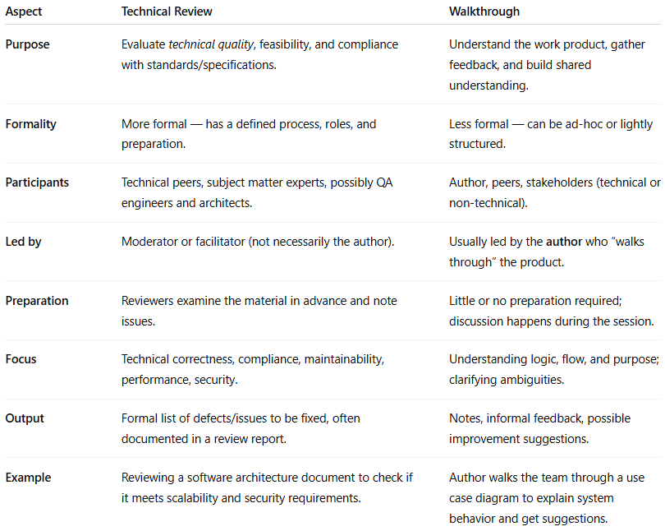
Aspect | Technical Review | Walkthrough
Purpose | Evaluate technical quality, feasibility, and compliance with standards/specifications. | Understand the work product, gather feedback, and build shared understanding.
Formality | More formal — has a defined process, roles, and preparation. | Less formal — can be ad-hoc or lightly structured.
Participants | Technical peers, subject matter experts, possibly QA engineers and architects. | Author, peers, stakeholders (technical or non-technical).
Led by | Moderator or facilitator (not necessarily the author). | Usually led by the author who “walks through” the product.
Preparation | Reviewers examine the material in advance and note issues. | Little or no preparation required; discussion happens during the session.
Focus | Technical correctness, compliance, maintainability, performance, security. | Understanding logic, flow, and purpose; clarifying ambiguities.
Output | Formal list of defects/issues to be fixed, often documented in a review report. | Notes, informal feedback, possible improvement suggestions.
Example | Reviewing a software architecture document to check if it meets scalability and security requirements. | Author walks the team through a use case diagram to explain system behavior and get suggestions.

💡 Quick way to remember:
- Technical Review → “Check if it’s technically right before we build it.” ✅🔍
- Walkthrough → “Let me show you what I made, and you tell me if it makes sense.” 🗣️👥
Alright — let’s strip away the jargon and make Technical Review vs Walkthrough crystal clear.

1️⃣ Imagine two scenarios
# Source: AI Source: Provided by: [Data Path: Persons Table -> ID Column: 1, Name_En Column: Motasem Essam] -> From: [Chatgpt (GPT‑5 Mini)] on [8/23/2025]

Scenario A — Technical Review
# Source: AI Source: Provided by: [Data Path: Persons Table -> ID Column: 1, Name_En Column: Motasem Essam] -> From: [Chatgpt (GPT‑5 Mini)] on [8/23/2025]
- You’ve drawn the blueprints for a new house.
- Before building, you call in architects and engineers.
- They don’t care about your “story” — they check math, safety codes, and structural integrity.
- They bring a checklist, mark problems, and give you a formal defect list to fix.
💡 This is Technical Review:
A formal, structured check for correctness against technical standards and requirements.

Scenario B — Walkthrough
# Source: AI Source: Provided by: [Data Path: Persons Table -> ID Column: 1, Name_En Column: Motasem Essam] -> From: [Chatgpt (GPT‑5 Mini)] on [8/23/2025]
- You’ve drawn the same house blueprint.
- You gather your friends, family, and maybe a contractor.
- You walk them through the drawing: “Here’s the living room, here’s the kitchen…”
- They ask questions: “Can the kitchen be bigger? Where’s the window?”
- You take notes and decide later what to change.
💡 This is Walkthrough:
An informal “show-and-tell” session to explain your work and get feedback for clarity and improvements.

2️⃣ Key Distinction
# Source: AI Source: Provided by: [Data Path: Persons Table -> ID Column: 1, Name_En Column: Motasem Essam] -> From: [Chatgpt (GPT‑5 Mini)] on [8/23/2025]
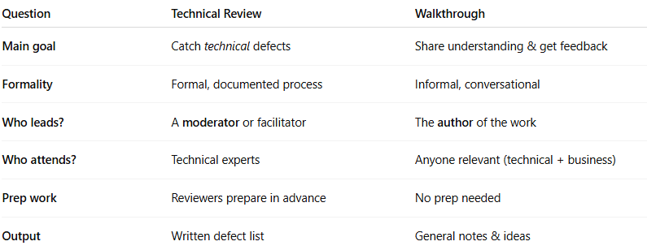
Question | Technical Review | Walkthrough
Main goal | Catch technical defects | Share understanding & get feedback
Formality | Formal, documented process | Informal, conversational
Who leads? | A moderator or facilitator | The author of the work
Who attends? | Technical experts | Anyone relevant (technical + business)
Prep work | Reviewers prepare in advance | No prep needed
Output | Written defect list | General notes & ideas

Think of it like this:
- Technical Review → “Quality control checkpoint” ✅🔍
- Walkthrough → “Story time + open feedback” 📖💬

Technical Review – Real Software Example
# Source: AI Source: Provided by: [Data Path: Persons Table -> ID Column: 1, Name_En Column: Motasem Essam] -> From: [Chatgpt (GPT‑5 Mini)] on [8/23/2025]
Artifact: API Design Document for a Payment Gateway
Activity: Technical Review session
Attendees: Senior backend developers, security engineer, architect, QA lead
What happens:
- Reviewers have the API spec before the meeting.
- Security engineer checks that card data handling follows PCI DSS.
- Architect verifies scalability and error handling.
- Backend devs spot inconsistent field names and a missing authentication flow.
- Findings are logged as formal defects in Jira.
Goal:
Catch technical issues before coding starts.
✅ Defect list is the outcome.

Walkthrough – Real Software Example
# Source: AI Source: Provided by: [Data Path: Persons Table -> ID Column: 1, Name_En Column: Motasem Essam] -> From: [Chatgpt (GPT‑5 Mini)] on [8/23/2025]
Artifact: New UI Prototype for a Banking Mobile App
Activity: Walkthrough session
Attendees: UX designer (author), product owner, QA tester, business analyst
What happens:
- Designer shares Figma screens during the meeting.
- Walks everyone through the login, account summary, and transfer flow.
- Product owner suggests adding “Quick Balance” view.
- Tester points out “Forgot Password” link is too small on mobile.
- Notes are taken, but no formal defect list — just improvement suggestions.
Goal:
Build shared understanding and get feedback for clarity & usability.
💬 Conversation is the outcome.

Side-by-side in software terms
# Source: AI Source: Provided by: [Data Path: Persons Table -> ID Column: 1, Name_En Column: Motasem Essam] -> From: [Chatgpt (GPT‑5 Mini)] on [8/23/2025]
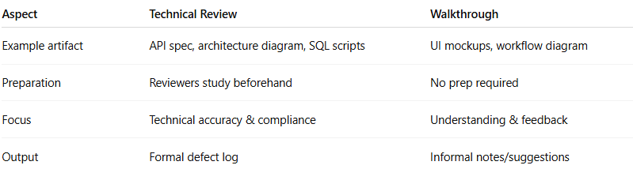
Aspect | Technical Review | Walkthrough
Example artifact | API spec, architecture diagram, SQL scripts | UI mockups, workflow diagram
Preparation | Reviewers study beforehand | No prep required
Focus | Technical accuracy & compliance | Understanding & feedback
Output | Formal defect log | Informal notes/suggestions

Real Testing Context: Technical Review vs Walkthrough
# Source: AI Source: Provided by: [Data Path: Persons Table -> ID Column: 1, Name_En Column: Motasem Essam] -> From: [Chatgpt (GPT‑5 Mini)] on [8/23/2025]
Got it — you don’t just want the textbook definition, you want to see exactly how Technical Review vs Walkthrough play out in real-world software testing, step-by-step, so you can tell them apart when you actually see them happening.
Let’s dive in.

1️⃣ Walkthrough in Real Testing
# Source: AI Source: Provided by: [Data Path: Persons Table -> ID Column: 1, Name_En Column: Motasem Essam] -> From: [Chatgpt (GPT‑5 Mini)] on [8/23/2025]
Scenario:
A QA engineer has just written 20 new test cases for a mobile banking app’s “Money Transfer” feature.
They want to make sure everyone understands the approach before executing them.
How it happens:
- Author-led session – The QA engineer shares their screen on Zoom with the Product Owner, another QA, and a developer.
- They say:
“Here’s Test Case #5: User transfers money to a new payee. Steps are here. Expected result: confirmation message.”
- The audience asks questions like:
  - “Should we also test when the amount exceeds the daily limit?” (Business analyst)
  - “What happens if the recipient account number is invalid?” (Developer)
- The QA engineer writes down these suggestions to consider updating the test cases.
- No defect log is created — just informal feedback.
- Outcome: Understanding improves, and new ideas for tests are noted.
Purpose:
✅ Share knowledge
✅ Gather broad feedback
🚫 Not a formal defect-finding process

2️⃣ Technical Review in Real Testing
# Source: AI Source: Provided by: [Data Path: Persons Table -> ID Column: 1, Name_En Column: Motasem Essam] -> From: [Chatgpt (GPT‑5 Mini)] on [8/23/2025]
Scenario:
Before the same test cases are approved for execution, the test lead wants to ensure they meet the testing standards and cover all requirements.
How it happens:
- Moderator-led process – The test lead sends the test cases to 3 senior QA engineers before the meeting.
- Reviewers prepare in advance by:
  - Checking traceability matrix → Does each requirement have a test?
  - Checking format → Are preconditions, steps, and expected results clear?
  - Checking for technical coverage gaps → Missing boundary value cases, missing negative tests.
- In the review meeting:
  - Reviewer:
“Test Case #5: Missing validation for when the transfer amount equals the maximum allowed limit.”
  - Reviewer:
“In Test Case #8, the expected result says ‘confirmation message,’ but requirement REQ-12 specifies the exact message text — please update.”
- All issues are logged in a defect tracking system (e.g., JIRA) as “Test Case Review Defects.”
- QA engineer updates the test cases based on these formal defects.
- Outcome: Verified, standard-compliant, complete test suite.
Purpose:
✅ Formal defect detection
✅ Technical correctness & compliance
✅ Documented results

Key Real-World Differences You’ll Notice
# Source: AI Source: Provided by: [Data Path: Persons Table -> ID Column: 1, Name_En Column: Motasem Essam] -> From: [Chatgpt (GPT‑5 Mini)] on [8/23/2025]
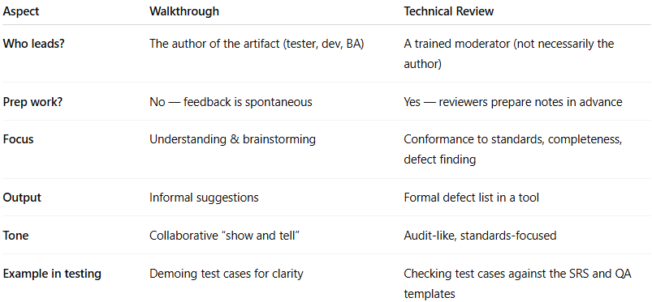
Aspect | Walkthrough | Technical Review
Who leads? | The author of the artifact (tester, dev, BA) | A trained moderator (not necessarily the author)
Prep work? | No — feedback is spontaneous | Yes — reviewers prepare notes in advance
Focus | Understanding & brainstorming | Conformance to standards, completeness, defect finding
Output | Informal suggestions | Formal defect list in a tool
Tone | Collaborative “show and tell” | Audit-like, standards-focused
Example in testing | Demoing test cases for clarity | Checking test cases against the SRS and QA templates

💡 Shortcut memory hook:
- Walkthrough → “Show me what you’ve got, let’s talk about it.” (Brainstorm)
- Technical Review → “Let’s inspect and mark every flaw against the checklist.” (Inspection)

